Course : Programming Fundamental – ENSF 337

Lab # : Lab 4

Instructor : M. Moussavi

Student Name : Nimna Wijedasa

Lab Section : B02

Date submitted : Oct 14, 2022

Exercise A

Exercise B

Exercise C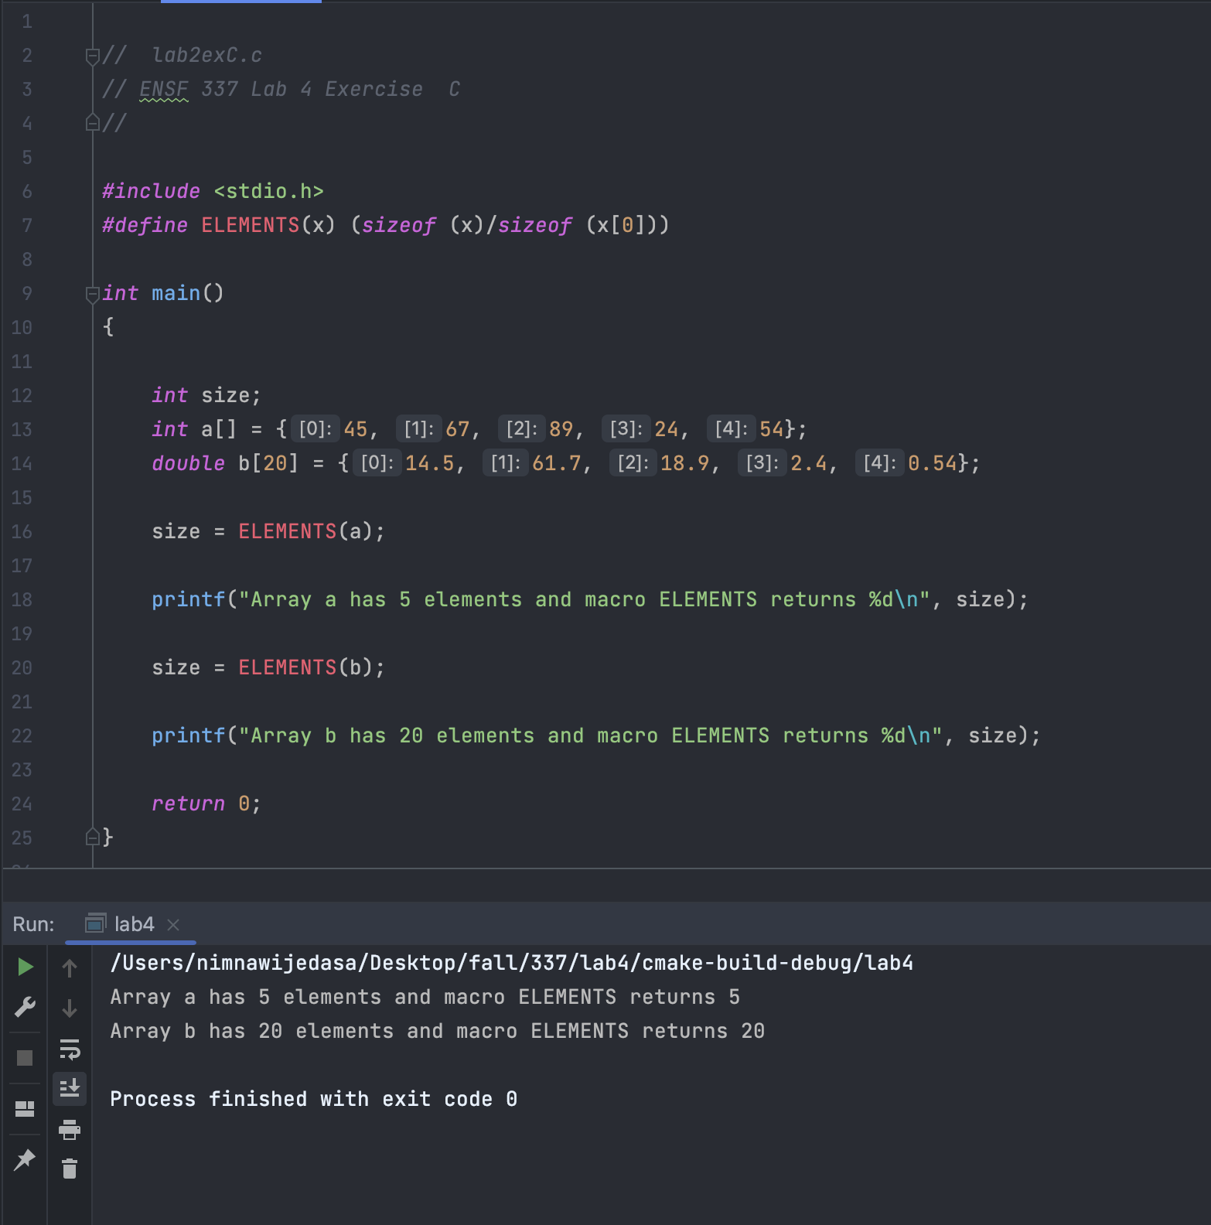

Exercise D

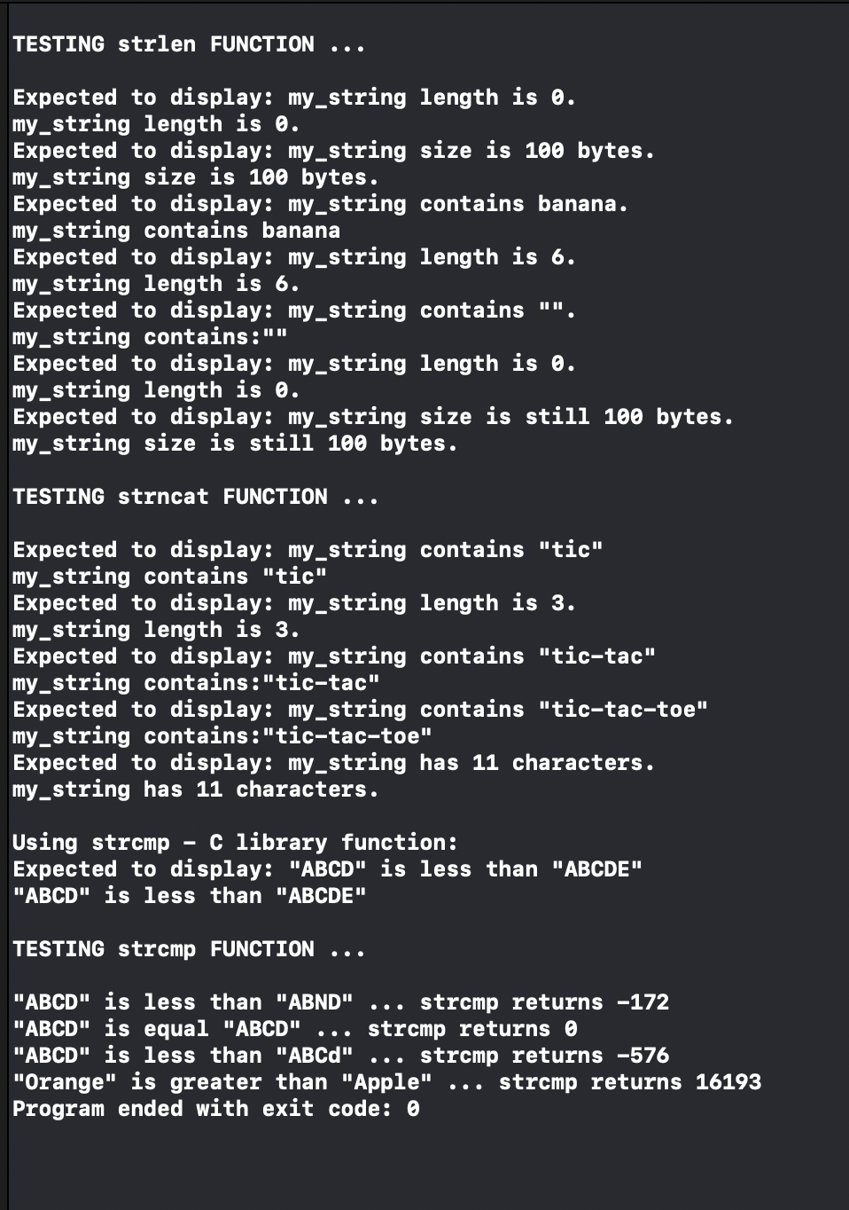

Exercise E

